STUDENT NAME: MOHAMED FARAH
ADMISSION NUMBER: BSCCS/2024/31995
COURSE: COMPUTER SCIENCE
UNIT CODE: BIT3208
UNIT NAME: ADVANCED WEB DESIGN AND DEVELOPMENT
LECTURER’S NAME: MICHAEL NYORO
ACADEMIC YEAR: YEAR IV SEM II
PROJECT DETAILS
PROJECT TITLE: SMARTSHOPKE
SELECTED TECHNOLOGIES: MEVN STACK
GITHUB LINK : https://github.com/Mohaaz1/advance-web-dev

WEEK 1 TASK 3
Setting up environments 3
Week 1 reflection 3
WEEK 2 TASKS 4
designing GUI wire-frames for the project 4
Week 2 reflection 5
WEEK 3 TASKS 5
variables and functions 5
TASK 1: 5
TASK 2: 6
TASK 3: 7
TASK 4: 8
Week 3 reflection 9
WEEK 4 TASKS 9
Week 4 reflection 9
WEEK 5 Tasks 9
Week 5 reflection 10
Week 6 tasks 10
Employee Records Management System 10
Library Book Management System 11
Student Management System 11
Week 6 reflection 12
WEEK 7 12
Employee Portal 12
Multi-User Authentication System 12
Student Portal Login System 13
Week7 reflection 13
Week 8 14
Responsive Product Showcase 14
Cake Training and Supplies Business 14
Responsive Personal Profile Page 14
Week 8 reflection 14

WEEK 1 TASK

Setting up environments
Node.js and npm were installed and verified as the core runtime and package manager for the MEVN stack back-end.
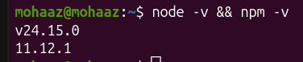
Figure i installation of node and npm
MongoDB was installed and confirmed as active and running as a system service on port 27017.
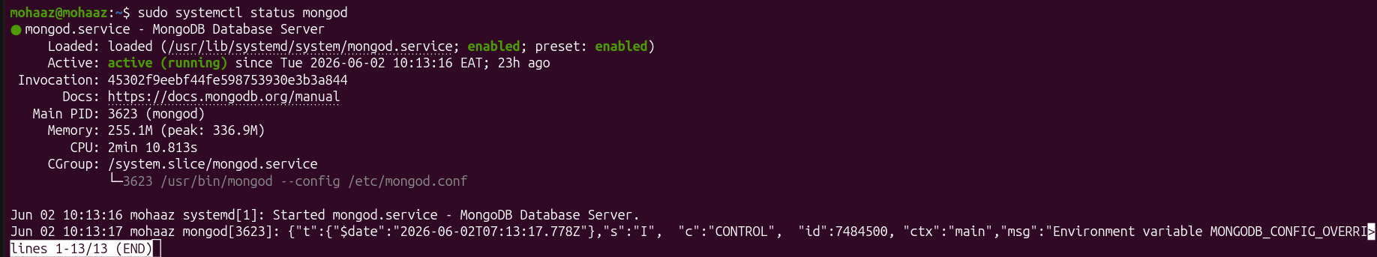
Figure ii verification of MongoDB
The MongoDB shell was used to test the database connection, returning ok: 1 to confirm successful connectivity.
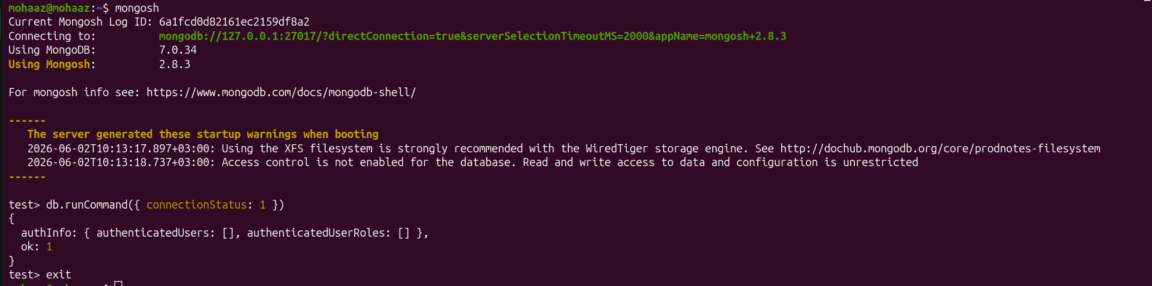
Figure iii testing of MongoDB functionality

Week 1 reflection
This week I successfully configured the development environment and gained practical experience with Node.js, npm, and MongoDB setup.

WEEK 2 TASKS

designing GUI wire-frames for the project
A wire-frame for the login page was designed showing the form layout and navigation flow.
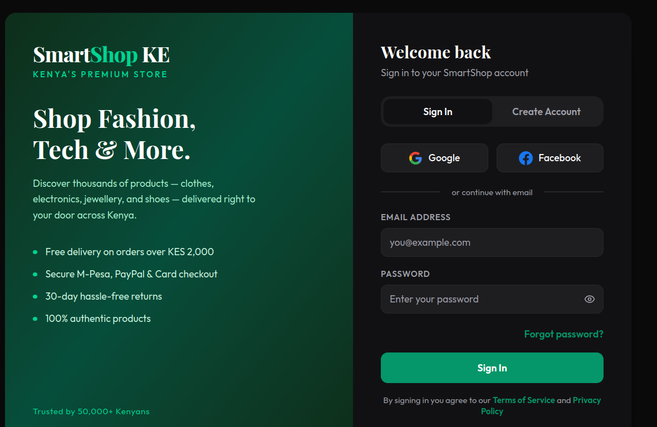
Figure iv login page
A wire-frame for the home page was designed showing the navigation bar and main content layout.
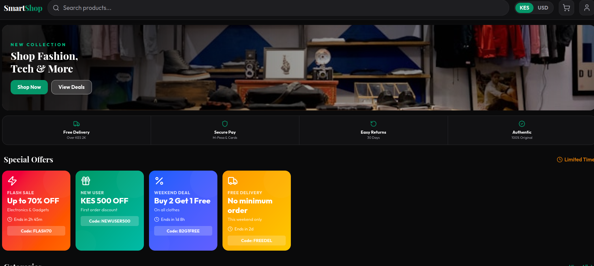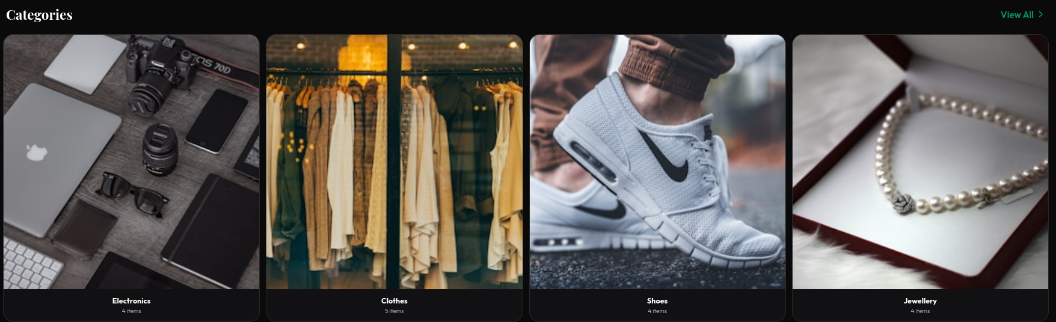
Figure v home page
A dashboard wire-frame was designed showing the sidebar, header and records management area
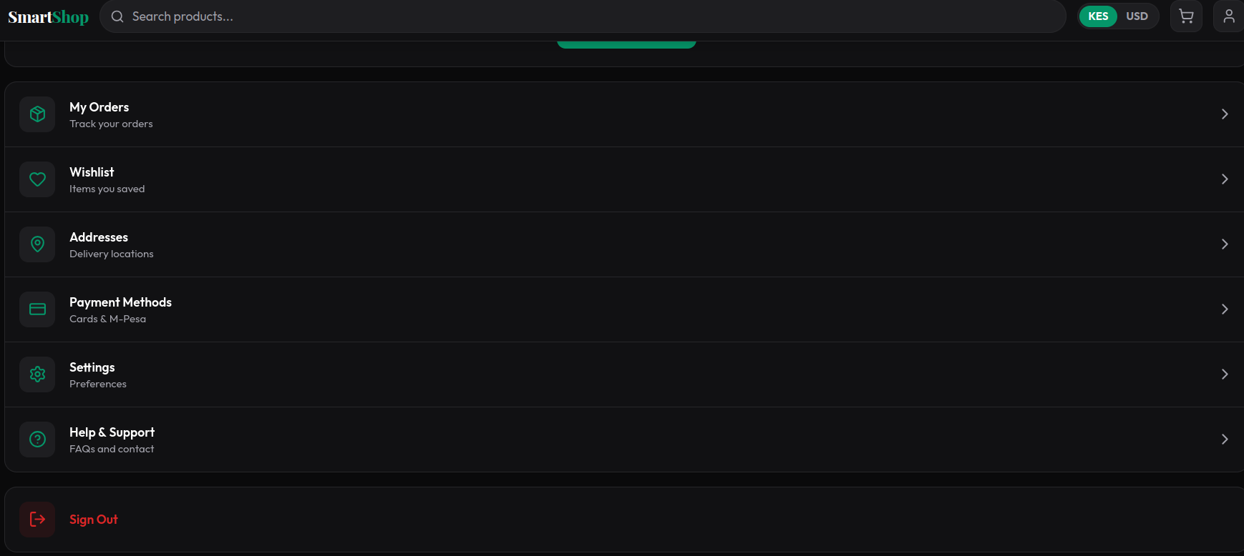
Figure VI dashboard
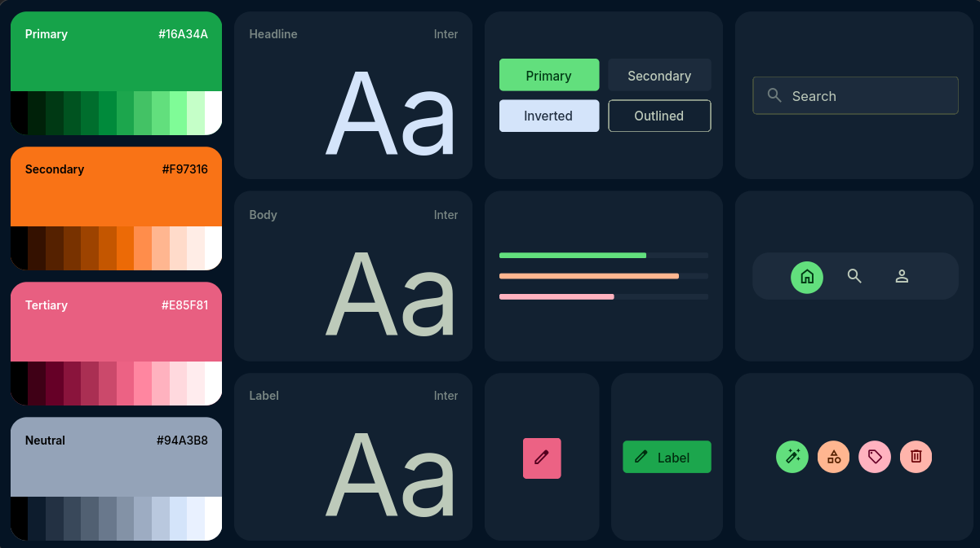
Figure VII theme

Week 2 reflection
This week I designed wire-frames for the login, home and dashboard pages while also establishing the visual blueprint for the SmartShopKE project. The activity improved my understanding of user interface planning and navigation flow before development begins.

WEEK 3 TASKS

variables and functions

TASK 1:
JavaScript variables, functions and events were demonstrated through a live name input that updates output in real time and logs every button click.

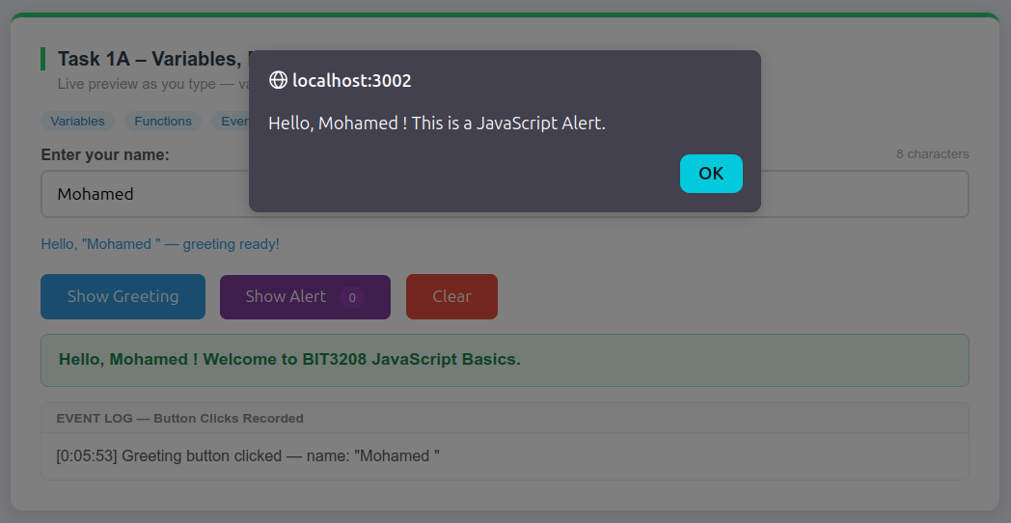
Figure viii Variables, Functions, Events & Alerts
A login form validation system was built that shows green or red borders with tick and cross icons as the user types.

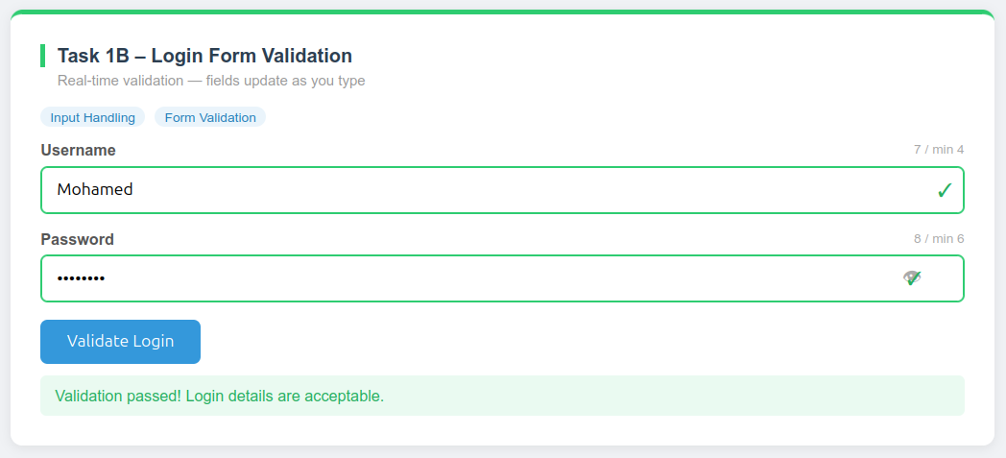
Figure ix Login Form Validation
Email validation was implemented using a regular expression that checks the format live as the user types.
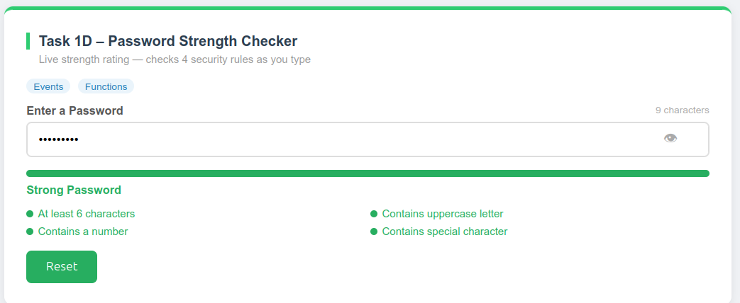
Figure x Email Validation

A password strength checker was built that rates passwords across four rules and displays a live colour-coded progress bar.
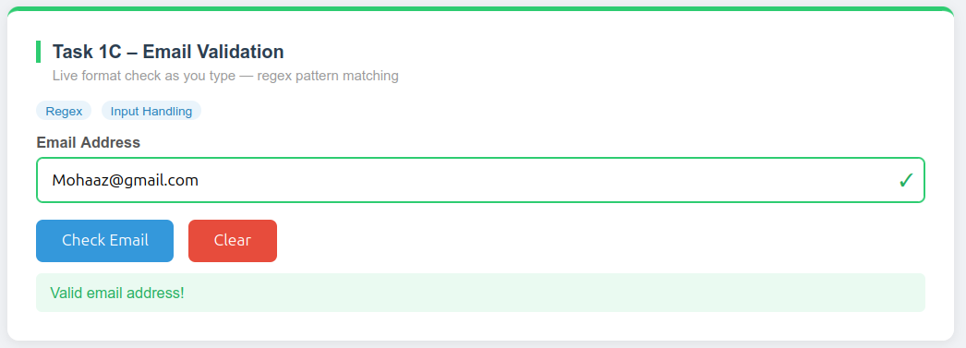
Figure xi Password Strength Checker

TASK 2:
A dynamic menu was built where items can be added and removed using JavaScript DOM methods.
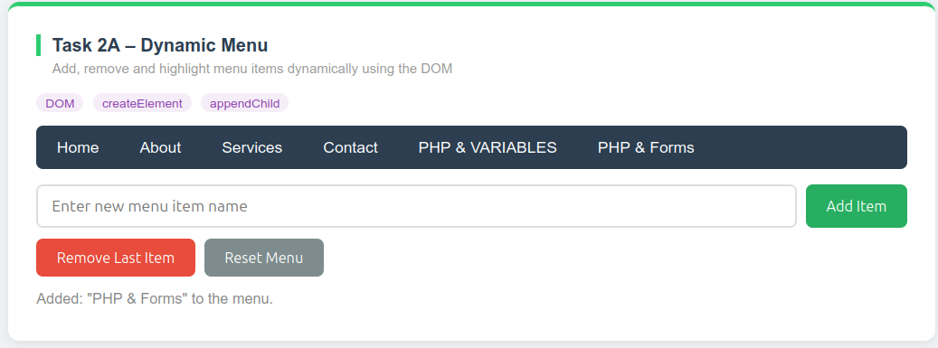
Figure xii Dynamic Menu
Interactive buttons were built to hide, show, recolor, resize and shake a demo element on the page.
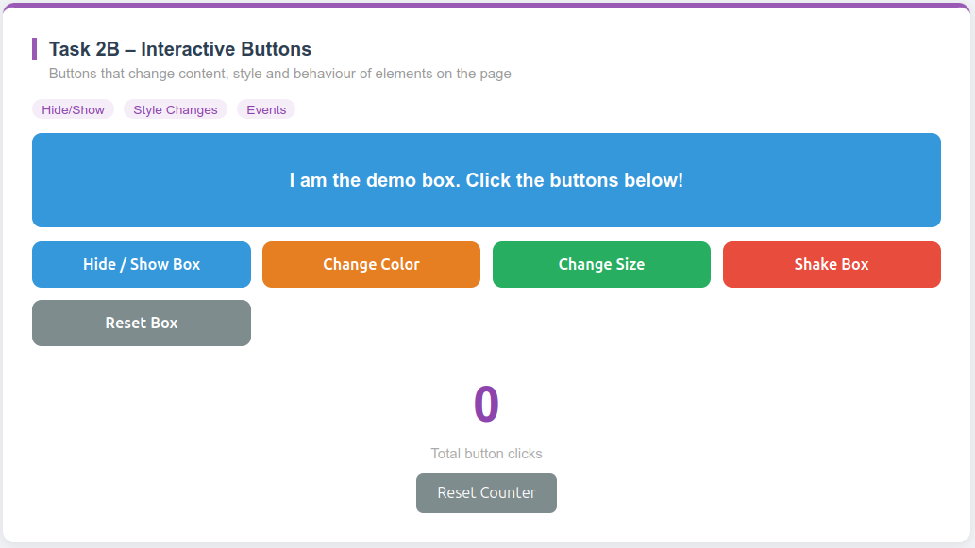
Figure xiii Interactive Buttons
A live text preview editor was built that mirrors formatted text from an editor panel to a preview panel in real time.

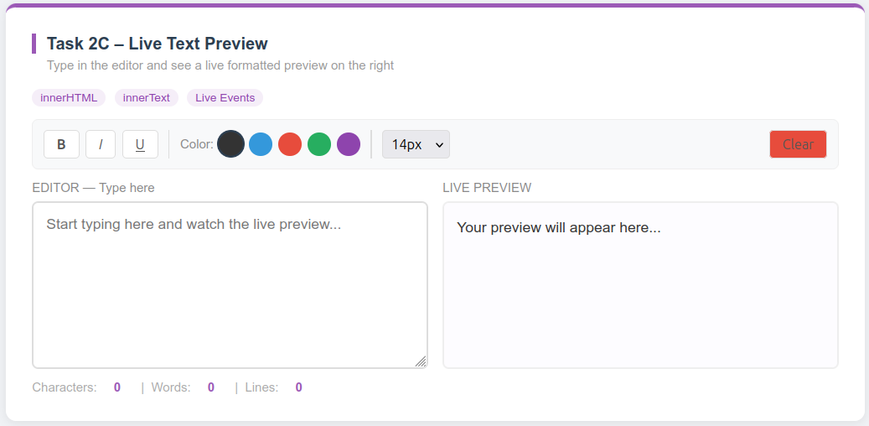
Figure xiv Live Text Preview

TASK 3:
A dynamic welcome page was built using Express.js to process a submitted name and return a personalized server-side response.
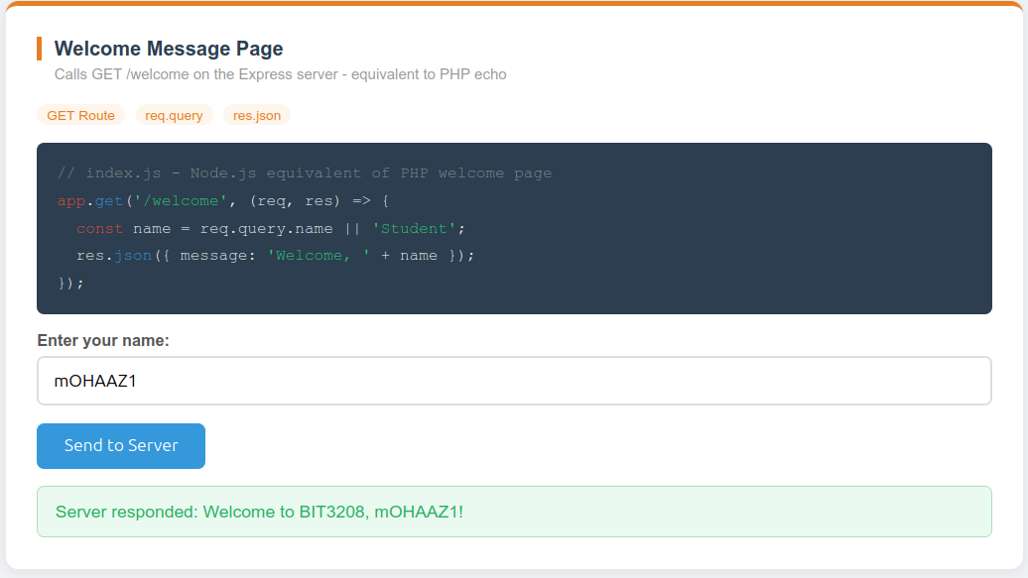
Figure xv Welcome Message Page
A simple form processor was built using Express.js to receive POST data and return a structured server response.
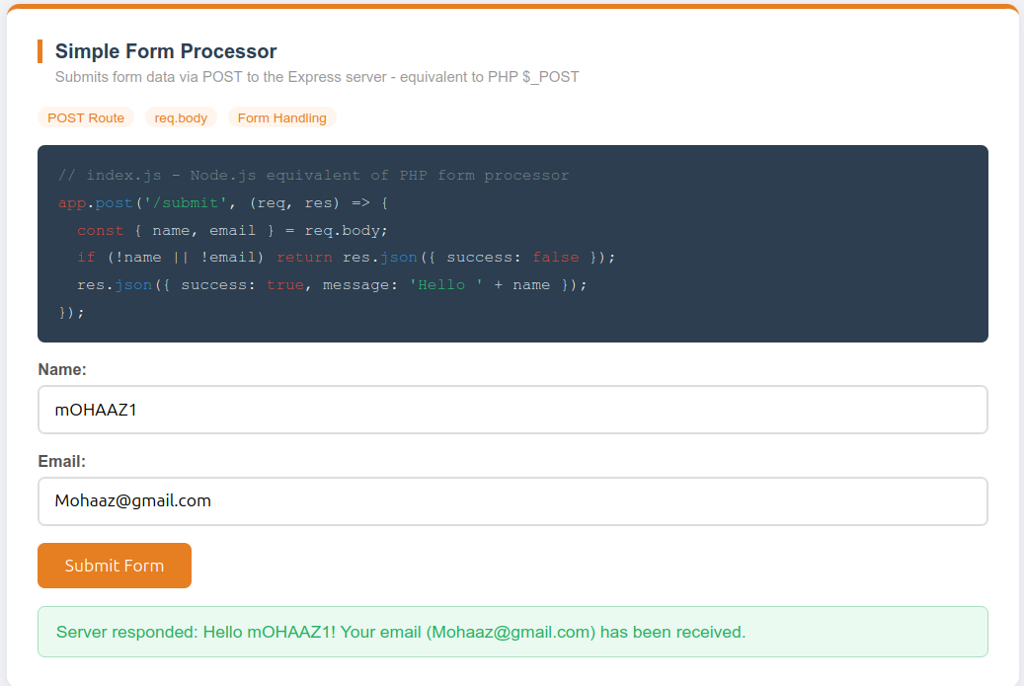
Figure xvi Simple Form Processor

TASK 4:
A database connection test was performed using Mongoose, confirming Node.js successfully connected to MongoDB.
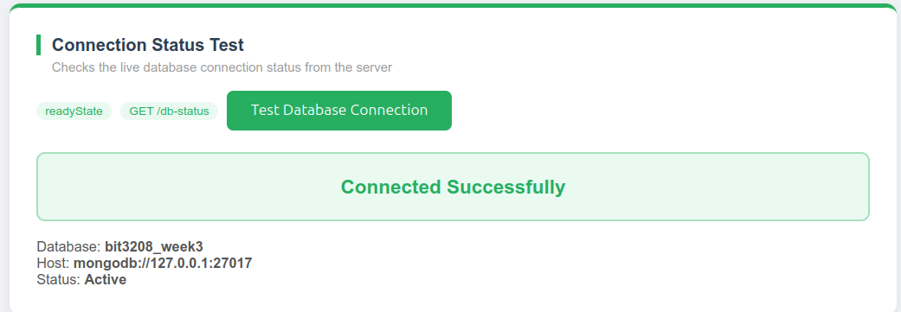
Figure xvii Database Connection Status Test
Week 3 reflection
This week I implemented JavaScript variables, functions, form validation and DOM manipulation and then extended the work to server-side processing with Express.js and a MongoDB connection via Mongoose. The tasks bridged front-end interactivity with back-end data flow, reinforcing my full-stack development understanding.

WEEK 4 TASKS
multi-step authentication system was built with a registration form, login form and session-based protected contact form using Node.js and Express.js.
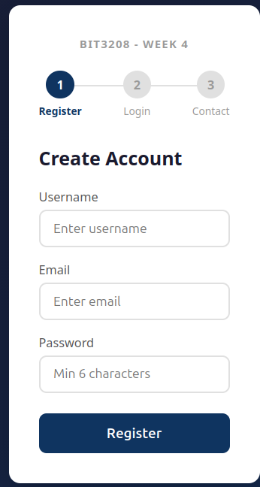
Figure xviii Multi-Step Registration Form

Week 4 reflection
This week I built a multi-step authentication system covering user registration, login and session-based access control using Node.js and Express.js. The task deepened my understanding of secure authentication workflows and server-side session management.

WEEK 5 Tasks
A full CRUD dashboard was built allowing records to be created, read, updated and deleted from a MongoDB database using Mongoose and Express.js.
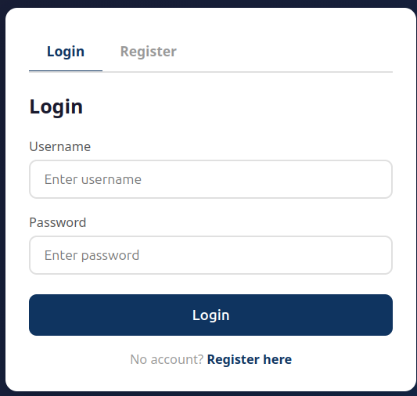
Figure xix CRUD Operations

Week 5 reflection
This week I developed a full CRUD dashboard enabling create, read, update and delete operations on a MongoDB database via Mongoose and Express.js. The task consolidated my understanding of RESTful data management and back-end API integration within a MEVN stack context.

Week 6 tasks

Employee Records Management System
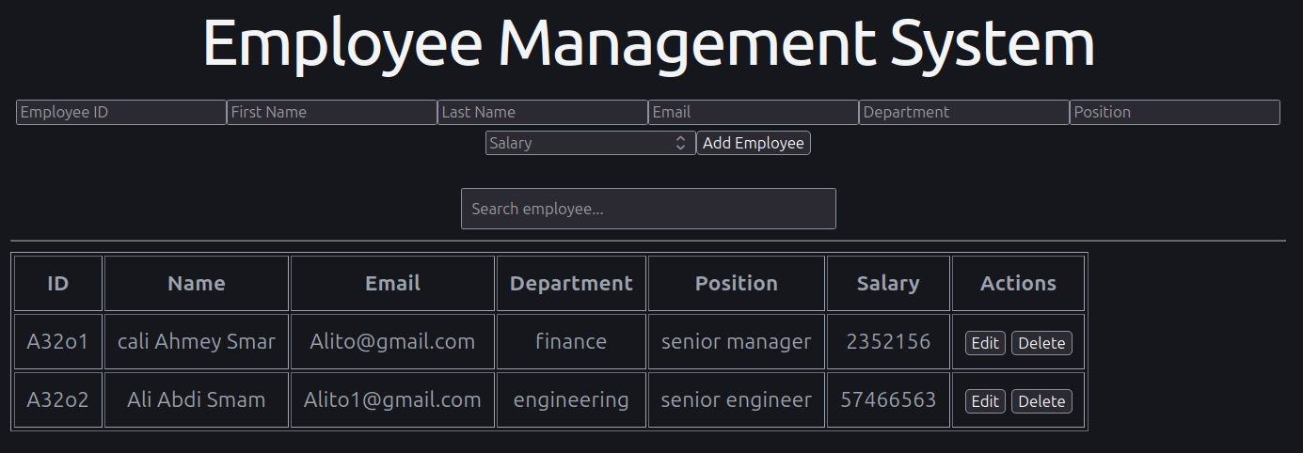
Figure xx Employee Records Management System

Library Book Management System
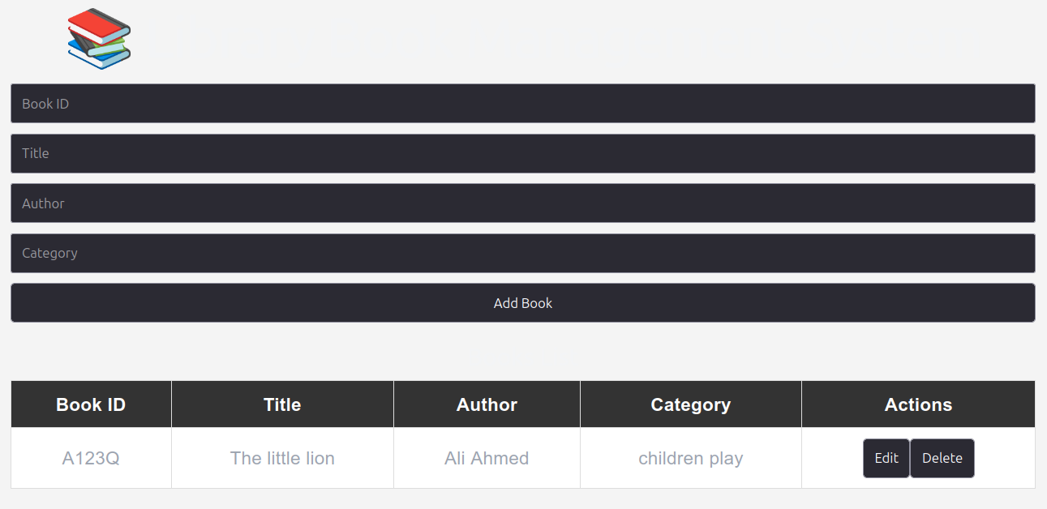
Figure xxi Library Book Management System

Student Management System
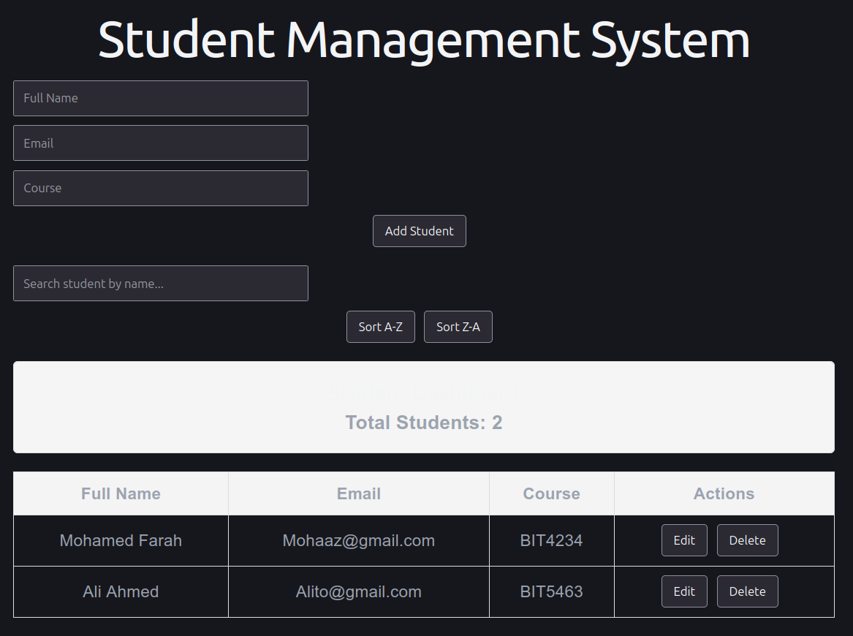
Figure xxii Student Management System

Week 6 reflection
This week I built three management systems for employees, library books and students while applying CRUD principles across different real-world data models. The experience strengthened my ability to design reusable back-end logic and adapt database schema to varied use cases.

WEEK 7

Employee Portal
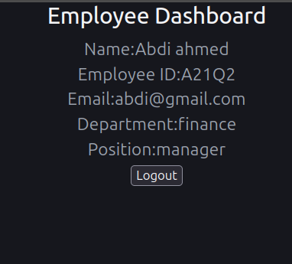
Figure xxiii Employee Portal

Multi-User Authentication System
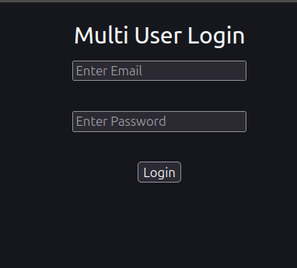
Figure xxiv Multi-User Authentication System

Student Portal Login System
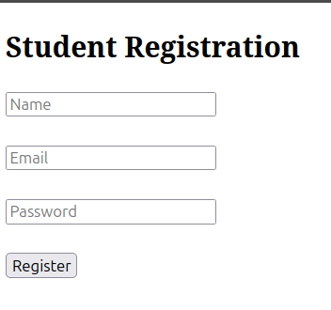
Figure xxv student registration

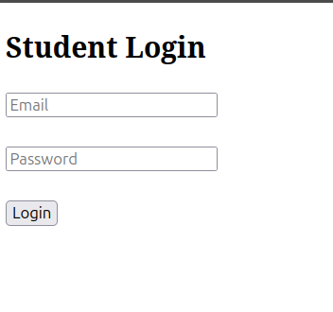
Figure xxvi student login

Week7 reflection
This week I implemented an employee portal, a multi-user authentication system and a student portal with registration and login functionality. Working across multiple portal types reinforced my understanding of role-based access control and user session management patterns.

Week 8

Responsive Product Showcase
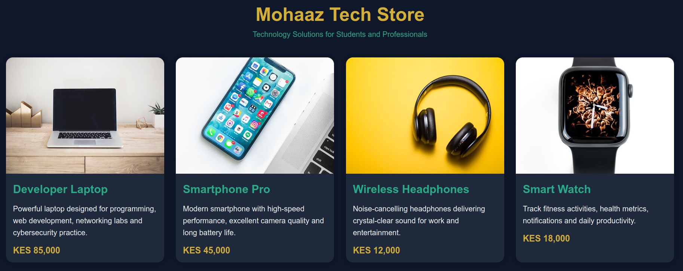
Figure xxvii Responsive Product Showcase

Cake Training and Supplies Business
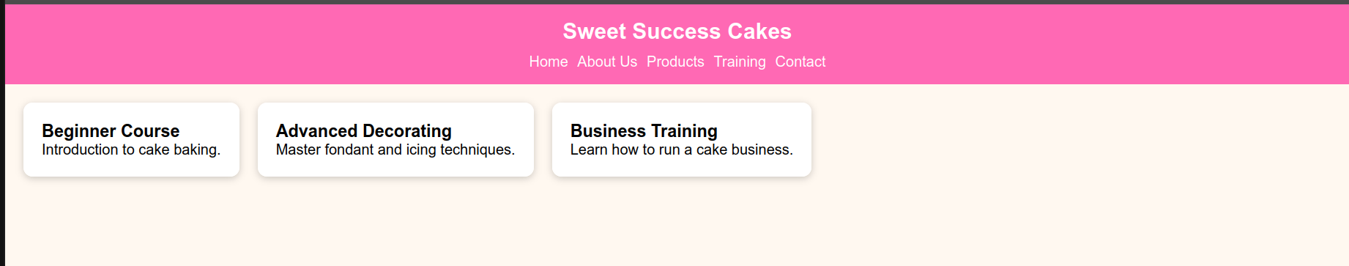
Figure xxviii Cake Training and Supplies Business

Responsive Personal Profile Page
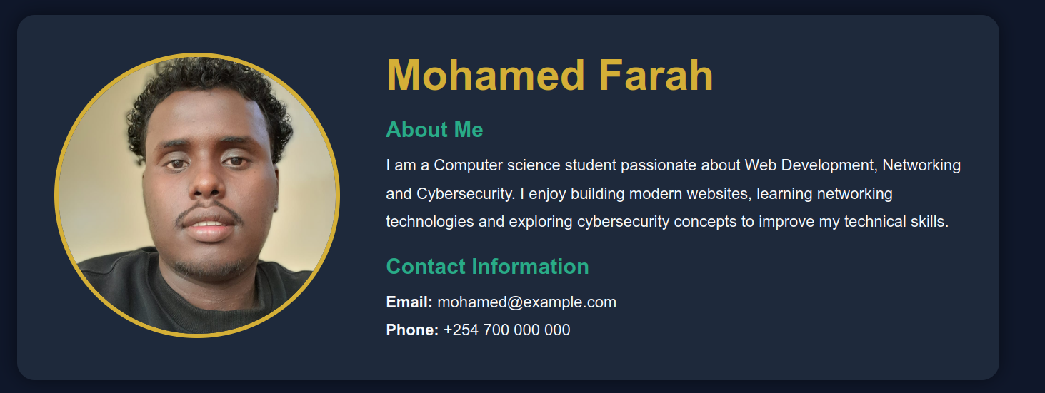
Figure xxix Responsive Personal Profile Page

Week 8 reflection
This week I developed responsive web pages including a product showcase, a business landing page and a personal profile page using CSS layout and responsive design techniques. The work solidified my ability to build adaptive interfaces that scale consistently across different screen sizes and devices.

